AKMEC GROUP is An ISO 9001:2015 certified Company trusted name for vigorous, sustainable, and tailored facilities management services to public and private organizations in India since 2021, creating value through expertise grow with AKMEC. AKMEC as a leader in Inspection, NDT, Advanced-NDT, Trading, filtration System, construction and facility management in India, translates professionalism and excellence.
We take pride in providing facility management solutions to our esteemed clients that are both customized and modern. At AKMEC, we believe in creating an experience tailored to our client's specific needs.
Find an efficient way of working with AKMEC, A total Facilities Management Services Company in India.

Mission : We strive to render services reflective of our efficiency and are committed to providing superior quality and results.
Vision : We aim to provide our clients with outstanding service, value, and quality. We will continue to achieve this goal through a total commitment to exceed the clients› expectations, personal attention, dedication, and just plain hard work.

Our Services
We offer a range of services to meet your needs

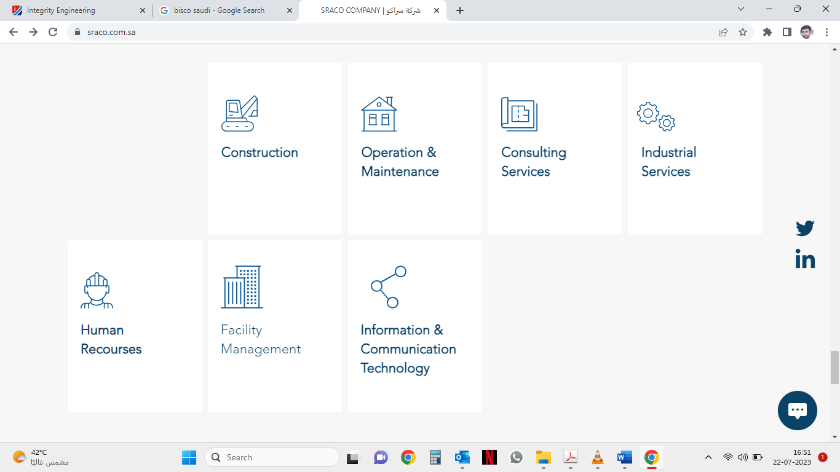(Attach photo of services)

